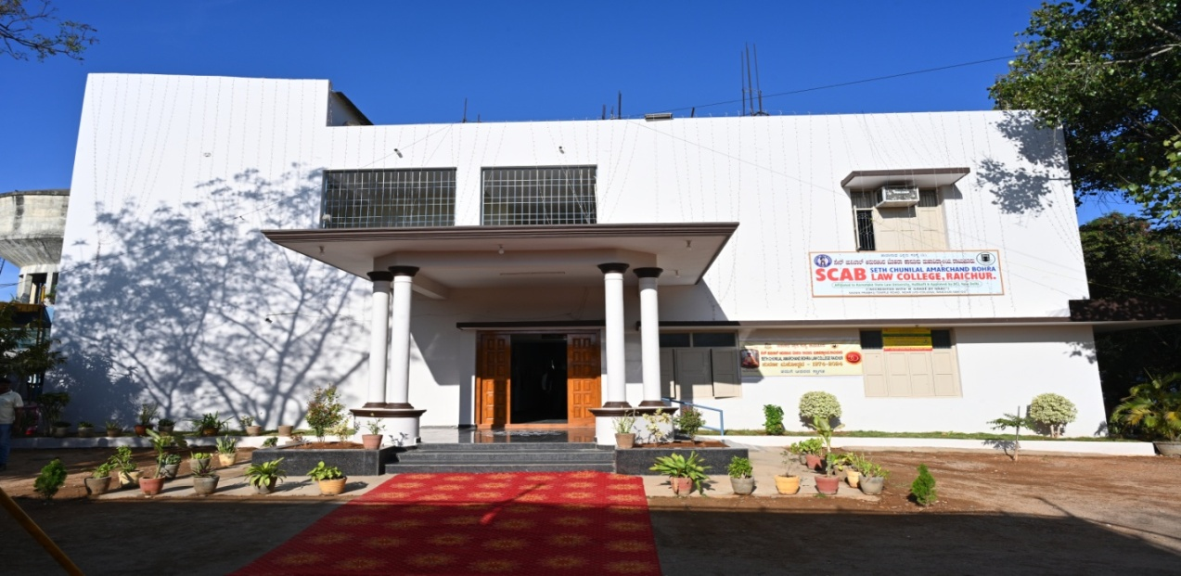

SETH CHUNILAL AMARCHAND BOHRA LAW COLLEGE, RAICHUR.

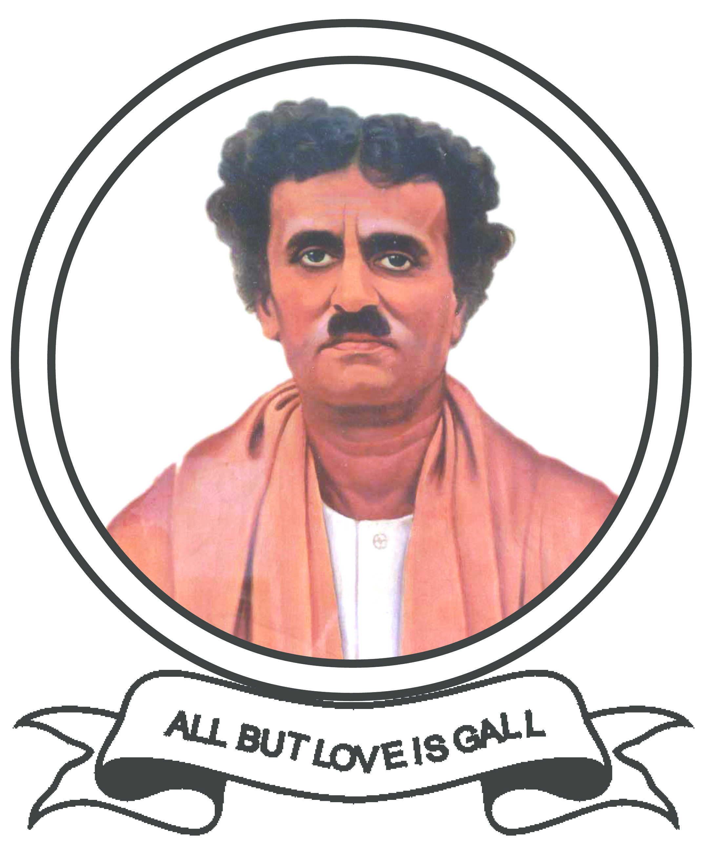 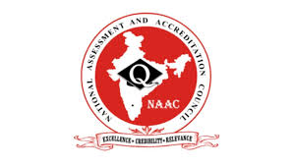   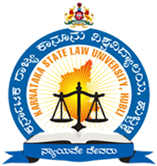

**(Estd :1974 )**

**Grant in Aid : 2015**

**Manikprabhu Temple Road, RAICHUR – 584103**

**Tel No : 08532 -240226 / 944815386**

**AFFILIATED TO KARNATAKA STATE LAW UNIVERSITY, HUBBALLI.**

**Aided by Government of Karnataka.**

**Approved and Recognized by Bar Council of India, NEW DELHI.**

**ACCREDITED WITH ‘B’ GRADE BY NAAC**

**Recognized under Sec 2 (f) & 12 B of UGC Act**

**AISHE CODE : C– 9825**

**Email id :** [**scablawcollege@gmail.com**](mailto:scablawcollege@gmail.com)

**CRITERION 3 - RESEARCH INNOVATION AND EXTENSION**

**Key Indicator - 3.4 Collaboration**

***Metric No. 3.4.1:*****Number of functional MoUs / linkages with institutions/ Law firms/ industries  in India and abroad for internship, on-the-job training, project work, student / faculty exchange and  collaborative research  during the last five years.**

|  |
| --- |
| VTaranath Shikshana Samsthe’s  **SETH CHUNILAL AMARCHAND BOHRA LAW COLLEGE**  RAICHUR – 584 103. ( Karnataka )  ( Affiliated to Karnataka State Law University, Hubballi )  (**“ACCREDITED WITH ‘B’ GRADE BY NAAC”)**  (**“**Recognized by Bar Council of India, New Delhi**”)**  anu.bmpDr. Padma.J Ph. (O) 08532-240226,/ 9448153186  Principal E-mail **:** [**Scablawcollege@gmail.com**](mailto:Scablawcollege@gmail.com)  Padmajjagirdar@gmail.com |

***Metric No. 3.4.1:*****Number of functional MoUs / linkages with institutions/ Law firms/ industries in India and abroad for internship, on-the-job training, project work, student / faculty exchange and  collaborative research  during the last five years.**

|  |  |  |  |
| --- | --- | --- | --- |
| **Name of the Organisation/ Institution/ Industry with whom MoU is signed** | **Year of signing MoU** | **Duration of MoU** | **List the actual activities under each MOU year wise** |
| **Rotary Club Raichur** | **2018** | **LIFE TIME** | **QUIZ COMPETITION CONDUCTED FOR THE STUDENTS** |
| **Inner Wheel Club Rachur** | **2018** | **LIFE TIME** | **WOMEN RIGHT AWARENESS PROGRAMME ORGANISED BY SHAKTI CELL OF SCAB LAW COLLEGE IN ASSOCIATION WITH INNER WHEEL CLUB RAICHUR** |
| **Lions Club Raichu** | **2018** | **LIFE TIME** | **Menstrual hygiene Awareness Programme Conducted by the Lions Club In Association with SHAKTI CELL SCAB LAW COLLEGE RAICHUR.** |
| **JNR Ladda Law College Sedam** | **2018** | **LIFE TIME** | **Five Days Workshop on Yoga was Organised jointly by the JNRL Law College, Patanjali yoga samiti and SCAB Law College, Raichur** |
| **Sidharth Law College Gulbarga** | **2019** | **LIFE TIME** | **Student Exchange Programme was conducted on** |
| **Seth Shankar Lahoti Law College, Gulbarga** | **2019** | **LIFE TIME** | **Student Exchange Programme was conducted on 30-07-2022** |
| **VjnaneshwaraGovt Law College, Gulbarga** | **2021** | **LIFE TIME** | **Faculty Exchange Programme was conducted on** |
| **SugureshwaraHighschool, Raichur** | **2020** | **LIFE TIME** | **Human Rights Awareness Proramme was conducted by the Institution in Association With Sugureshwara High School, Raichur on 26-11-2020** |
| **NGO School Raichur** | **2021** | **LIFE TIME** | **legal awareness programme on 23.10.2021** |
| **District RED CROSS , Raichur** | **2021** | **LIFE TIME** | **NSS Programme Officer’s Meeting was conducted by the District Red Cross on 18-12-2019 First Aid TrainingProgramme was Conducted by the District RedCross where our Students Participated on 16-03-2022** |
| **Govt School Baidoddi, Raichur** | **2021** | **LIFE TIME** | **Legal Awareness Programme was conducted on 27-1-2023** |
| **Govt School Bijanagera, Raichur** | **2021** | **LIFE TIME** |  |
| **Govt School GouseNagara, Raichur** | **2021** | **LIFE TIME** | **Legal Awareness Programme was conducted on 27-1-2023** |
| **Govt School Kdagumdoddi, Raichur** | **2021** | **LIFE TIME** | **Legal Awareness Programme was conducted on 28-1-2023** |
| **Govt PU College, Munnurwadi, Raichur** | **2021** | **LIFE TIME** | **Constitutional Awareness Programme 26-11-2022** |
| **Srikanth Y Advocate, Raichur** | **2021** | **LIFE TIME** | **Internship** |
| **Girija Madam Advocate** | **2021** | **LIFE TIME** | **Internship** |
| **Agricutre University, Raichur** | **2022** | **LIFE TIME** | **Accomodation was Provided by the University in their Guest House to the Participant of Youth Festival held on** |
| **TalukaSahityaParishath, Raichur** | **2022** | **LIFE TIME** | **Edowment lecture was orgnised by TalukaSahityaParishth, Raichur14-09-2023** |
| **Sri. M. NagappaPrathisthan, Raichur** | **2022** | **LIFE TIME** |  |
| **City XI Cricket Academy Raihur** | **2022** | **LIFE TIME** | **Blood Donation Camp was organized jointly** |
| **COLLABRATIVE ACTIVITIES without MOUs** | | | |
| **All Idia Radio FM, Raichur** | **2018** | **Awreness** | **Leagal Awareness on Eve of Internation Women's Day** |
| **Art of Living, Raichur** | **2019** | **Awareness** | **Drugs Free India Awareness Programme** |
| **Navodaya Engineering College, Raichur** | **2019** | **Awareness** | **Legal Awareness on Hindu Marriage Act** |
| **SLN Engineering College, Raichur** | **2020** | **Awareness** | **Legal Awareness on CriminalJusticeSystem and Rule of Law** |
| **Disrict Legal Servicess Authority, Raichur and BAR Association, Raichur** |  | **Azadi Ka Amrut Mahotsv** | **1. Legal Awareness at NGO School, Raichur 2.Legal Awareness at Govt High School Gajgarpeth, Raichur 3.Legal Awareness at Humdard PU College, Raichur 4.Legal Awareness at Humdard PU College, Raichur 5.Constitutiona Awareness Programme at SSRG Womens, College, Raichur** |
| **Disrict Legal Servicess Authority, Raichur and BAR Association, Raichur** | **2019** | **Awareness** | **Prention of Women Traffiking an Awareness Programme** |
| **District Administration** |  | **Awareness** | **Voting Awareness Programmes were Conducted** |
| **Disrict Social Welfare Deparment, Raichur** |  | **Awareness** | **Legal Survey at Bagwat,** |
| **Disrict Child ProtctionOfiice, Raichur** |  | **Awareness** | **Students Participated as legal Volunteers During the Visit of National Child Rights Commission New Delhi’s Visit and Hearing of Child related Issues** |
| **Disrict Health Department, Raichur** |  | **Awareness** | **Covid-19 Vaccination** |
| **Disrict Kannada and samskruti Department, Raichur** |  | **Awareness** | **SamskrutikaSambrahma and other Cultural events were conducted** |
| **Department of Law and Justice Govt Of India in Association with SCAB Law College CEERA( NLSIU) Banglore.** | 2022 | **Awareness** | **One Day Workshop On Legal Litteracy and Legal Awareness** |
| **District Legal Services Athority ,Raichur** | 2023 | **Awareness** | **One Day State Level Seminaron Intelectual Property Rights** |