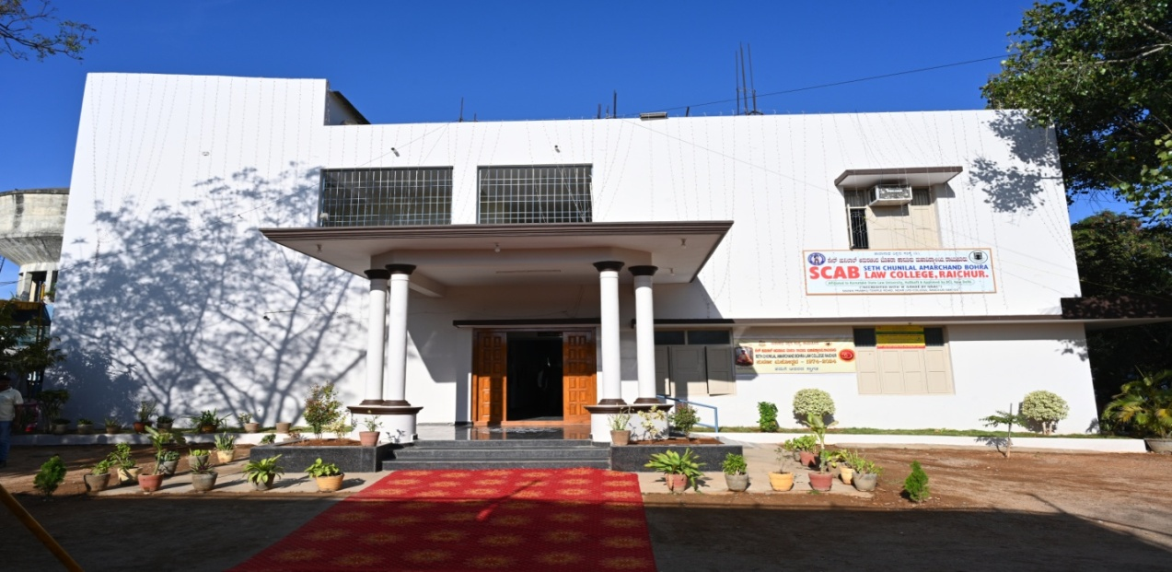

SETH CHUNILAL AMARCHAND BOHRA LAW COLLEGE, RAICHUR.

    

**(Estd :1974 )**

**Grant in Aid : 2015**

**Manikprabhu Temple Road, RAICHUR – 584103**

**Tel No : 08532 -240226 / 944815386**

**AFFILIATED TO KARNATAKA STATE LAW UNIVERSITY, HUBBALLI.**

**Aided by Government of Karnataka.**

**Approved and Recognized by Bar Council of India, NEW DELHI.**

**ACCREDITED WITH ‘B’ GRADE BY NAAC**

**Recognized under Sec 2 (f) & 12 B of UGC Act**

**AISHE CODE : C– 9825**

**Email id :** [**scablawcollege@gmail.com**](mailto:scablawcollege@gmail.com)

**CRITERION 1 - CURRICULAR ASPECTS**

**Key Indicator - 1.3 Curriculum Enrichment**

**1.3.3 Percentage of students undertaking Moot Courts, Court visits, Arbitration/Mediation/Client Counseling Exercises, and internship in law firms/NGOs/Judicial Clerkships etc.,(Data to be given for the latest completed academic year)**

|  |
| --- |
| Taranath Shikshana Samsthe’s  **SETH CHUNILAL AMARCHAND BOHRA LAW COLLEGE**  RAICHUR – 584 103. ( Karnataka )  ( Affiliated to Karnataka State Law University, Hubballi )  (**“ACCREDITED WITH ‘B’ GRADE BY NAAC”)**  (**“**Recognized by Bar Council of India, New Delhi**”)**  anu.bmpDr. Padma.J Ph. (O) 08532-240226,/ 9448153186  Principal E-mail **:** [**Scablawcollege@gmail.com**](mailto:Scablawcollege@gmail.com)  Padmajjagirdar@gmail.com |

**1.3.3 Percentage of students undertaking Moot Courts, Court visits, Arbitration/Mediation/Client Counseling Exercises, and internship in law firms/NGOs/Judicial Clerkships etc.,(Data to be given for the latest completed academic year)**

|  |  |
| --- | --- |
| **URL Address** | |
| **File – 1** | [**https://assessmentonline.naac.gov.in/storage/app/hei/SSR/100583/1.3.3_1713271158_10825.pdf**](https://assessmentonline.naac.gov.in/storage/app/hei/SSR/100583/1.3.3_1713271158_10825.pdf) |
| **File – 2** | [**https://assessmentonline.naac.gov.in/storage/app/hei/SSR/100583/1.3.3_1713094229_10825.pdf**](https://assessmentonline.naac.gov.in/storage/app/hei/SSR/100583/1.3.3_1713094229_10825.pdf) |